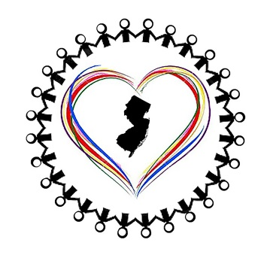

North Jersey Interfaith Cares Presents…

HUMAN TRAFFICKING
Rev. Mandy Leverett
CAN (Church and Community Abolition Network)
WAYNE YMCA, 1 PIKE DRIVE, WAYNE
SUNDAY, OCTOBER 13, 2:30-4:00
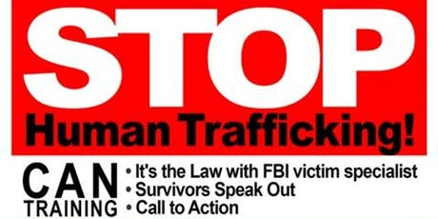
PARTICIPATE… PARTNER… PRAY
CAN Human Trafficking Community and Professional Training explores the six forms of human trafficking and modern day slavery in the USA. Learn the warning signs, and what we can do to respond, rescue, and prevent!

