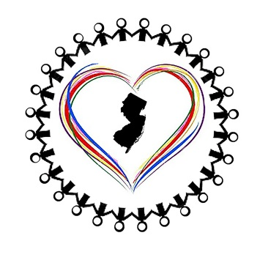

North Jersey Interfaith Cares Presents…

Come learn what YOU can do to help support asylum seekers upon their legal release from custody.

SUNDAY, NOVEMBER 3
2:30 – 4:00
WAYNE YMCA, 1 PIKE DRIVE, WAYNE
“Promoting compassion and hope through volunteer visitation, resettlement assistance, and advocacy.”

