Dine and Donate for
North Jersey Interfaith Cares

Applicable at any
of our 3 locations:

31 Passaic Avenue
Fairfield, NJ 07004

6 Wanaque Ave
Pompton Lakes, NJ 07004

53 Broadway
Denville, NJ 07834

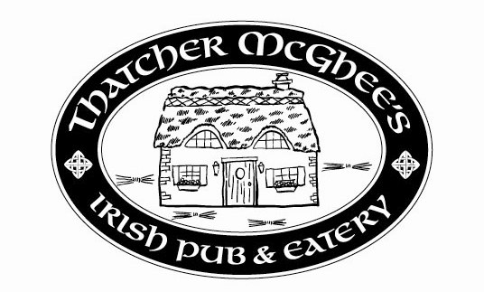
Open Mon thru Sun
11 AM to 2 AM

Party Rates Available with Dinner Menus & Buffet Menus

Check our website for weekly specials:
www.thatchermcghees.com

YOU MUST PRESENT THIS FLYER FOR THIS DONATION TO COUNT!!!

By dining at any Thatcher McGhee’s location on
Monday November 12 – Thursday November 15
North Jersey Interfaith Cares will receive
20% of the sales!

Please give this flyer to friends, family, and neighbors! Help us raise as much money as we can!!

