You are cordially invited to the
First Annual Fundraising Dinner
North Jersey Interfaith Cares
For the benefit of local Syrian Refugees
Thursday, September 27th, 2018
Doors open at 6:30pm
Bethwood
38 Lackawanna Avenue
Totowa, NJ 07512
Music by World Renowned pianist and former refugee Tambi Cimuk
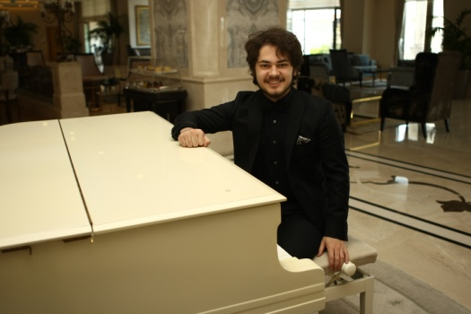
__________________________________________________________________________________________________________
I will attend, please reserve ____ tickets at $75.00
I will attend, please reserve a table of _______ at $75.00 per ticket
I am unable to attend but would like to make a donation in the amount of $__________
My choice of dinner is ____ Chicken ___ Vegetarian ___ kosher ___ Halal
Please send this section along with your check payable to North Jersey Interfaith Cares at NJIC, PO BOX 3192, Wayne, NJ 07474-3192

