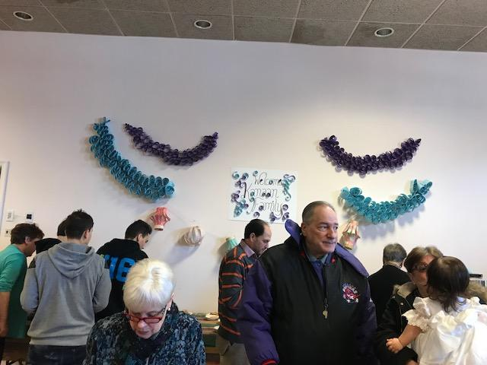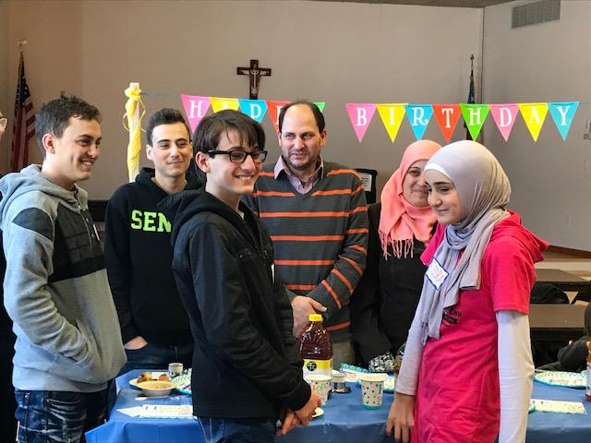

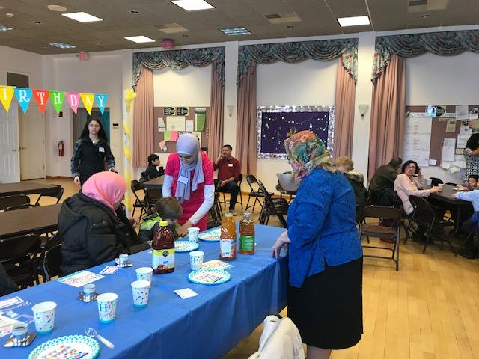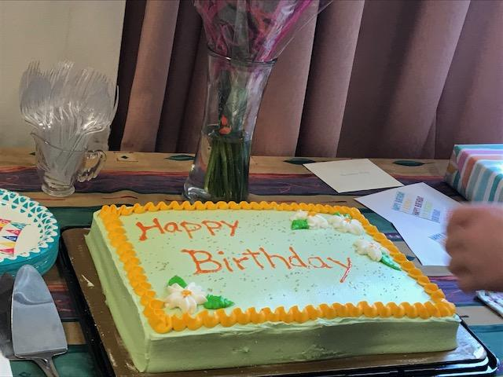

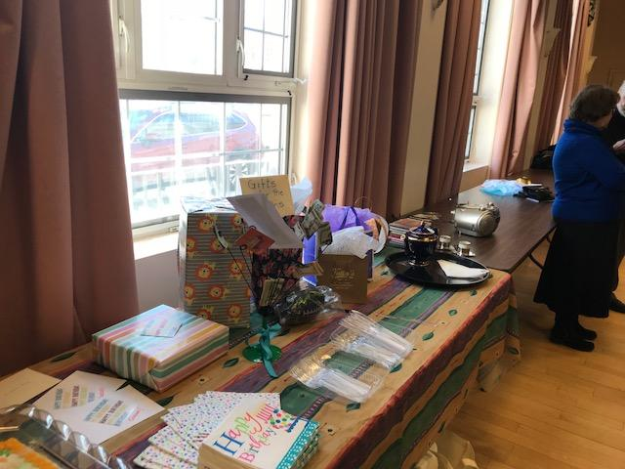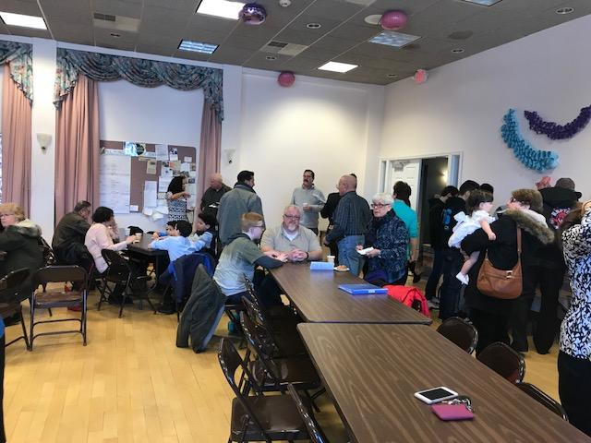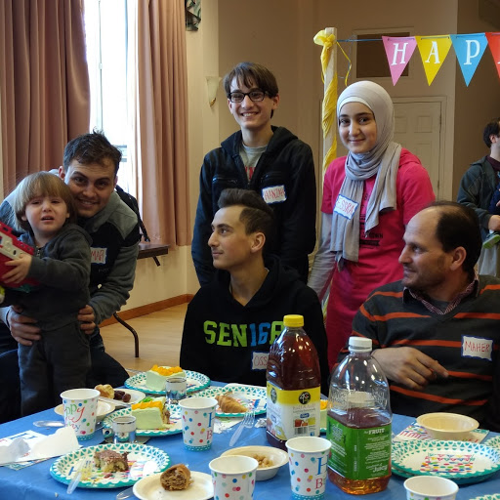

Snow couldn’t stop our Birthday Party as we welcomed the Kanaan family to Christ Church on February 18, 2018, to celebrate their January birthdays.

Meher, Fatima and their family, joined us in fellowship at our Coffee Hour after the 9:30 service. Father Stephen welcomed them at the end of the service where they were received with a round of applause and warm smiles.

We cant wait until they visit again!

HAppy birthday kanaans!